Last time we looked at the grid stucture, now we are going to look at framesets! If you have used something HTML before, framesets should be very familiar to you. If you don’t know framesets, then you should consider following the normal basic tutorial as this will not explain to you what they are.

Enable the mark variable in the create event of obj_uiZ_frame again by replacing:

[CODE]  
mark=false//b//mark

[/CODE]

With:

[CODE]  
mark=true//b//mark

[/CODE]

Now that we’ve replaced that we can see what we are doing.

**Creation of framesets.** A shall be created using:

* Uiz_frameset_create. (uiz_c(obj_uiZ_frameset) will work just as well).
* Some uiz_framedivision scripts with proper usage.
* Fixing the frameset using uiz_fixgeneralpos().

Now let’s look at some functions. The function for a horizontal cut is **uiz_framedivisionhorizontal(object,divisionval,valuetype[px dp or fc],divisionval,valuetype[px dp or fc],........)**, and the one for a vertical cut is: **uiz_framedivisionvertical(object,divisionval,valuetype[px dp or fc],divisionval,valuetype[px dp or fc],........)** These functions return a **frameanchor.** The first argument can refer to a few different objects: The frameset or a frame inside the frameset. What it can NEVER refer to are: frameanchors (what a divisionscript returns) or a frameset that already had a division. YOU CANNOT USE THIS FUNCTION ON A FRAMESET IF YOU’VE ALREADY MADE A DIVISION USING THAT FRAMESET.

**Frameanchors** are instance id’s returned by the uiz_framedivisionhorizontal/vertical scripts, and they hold an array called “frameat” which holds all the frames inside your division.

We can add as many frames in a uiz_framedivision script as game maker supports arguments.

Finally here is some example code:

EXAMPLE 39:

[CODE]

//init uiz

uiz_init()

//create frameset

frset=uiz_frameset_create()

//divide horizontally

div1=uiz_framedivisionhorizontal(frset,1,dp,1,xtra)

topbar=div1.frameat[0];//the top frame

mainpart=div1.frameat[1];//this variable will be unusable after our second devision

//divide vertically

div2=uiz_framedivisionvertical(mainpart,0.1,fc,3,xtra,1,xtra)

leftframe=div2.frameat[0];//the left bar

mainframe=div2.frameat[1];//the big, bottom-right frame.

rightframe=div2.frameat[2];//an extra frame on the right, created by supplying more argumetns to uiz_framedivisionvertical

//fix our frameset

uiz_fixgeneralpos(frset)

grad=uiz_c(obj_uiZ_gradientsquare)

//put it in the mainframe

uiz_setparent(grad,mainframe)

//fill the frame

grad.posinframex=uiz_fill;

grad.posinframey=uiz_fill;

//fix the gradient

uiz_fixgeneralpos(grad)

[/CODE]

IMAGE 52:

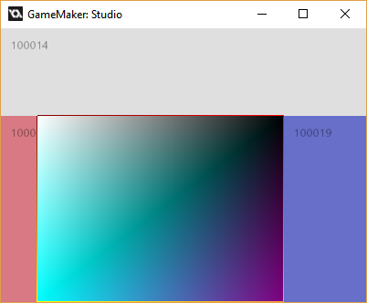

*\*mark frames is turned on here*

Now you should fully understand how to use framesets. There are a few more functions about which you can find more information in the manual/documentation. Those functions aren’t that important and you won’t be using them that often. You should by now be able to make structured ui’s. Next time we’ll talk about windows, another important feature of uiz.